**Bevacizumab for Metastatic Colorectal Cancer with Chromosomal Instability: An Cost-Effectiveness Analysis of a Novel Subtype across the COLOSSUS Partner Countries**

Jonathan Briody (1) | Kathleen Bennett (1) | Lesley Tilson (2)

1. Data Science Centre, RCSI University of Medicine and Health Sciences, Dublin, Ireland
2. National Centre for Pharmacoeconomics, St James Hospital, Dublin 8, Ireland

**Background:** Colorectal cancer is the third most common cancer in Europe. Bevacizumab, a monoclonal antibody that functions as an angiogenesis inhibitor, was approved for the first-line treatment of metastatic colorectal cancer (mCRC) in 2004. However, the addition of Bevacizumab to first-line chemotherapy in mCRC consistently fails to be cost-effective due to modest response in patients. Recently, the ANGIOPREDICT study has identified patients with improved outcomes following Bevacizumab combination therapy. The objective of this study was to compare the cost-effectiveness of adding Bevacizumab to first-line treatment chemotherapy, in comparison to chemotherapy alone, for such patients.

**Materials and Methods:** We developed a three-state Markov model with fortnightly cycles to estimate the incremental cost-effectiveness ratio (ICER) of Bevacizumab (Avastin) plus FOLFOX (5-FU, leucovorin, and oxaliplatin) versus FOLFOX alone. Progression risks and cause-specific mortality were informed by progression-free survival and overall-survival data from the ANGIOPREDICT study on this newly identified type of patient with improved responsiveness to Bevacizumab. Probabilities of adverse events were taken from the literature on Bevacizumab combination therapy. Costs for treatment administration and management of adverse events were derived from surveys of consortium hospitals in the participating countries and previously published studies. Utilities applied to calculate the quality-adjusted life years (QALYs) were obtained from a review of the literature. The perspective was that of a healthcare payer in the countries of the COLOSSUS translational study (Germany, Ireland and Spain), where the cost-effectiveness model was built. To test the robustness of results, parameter values were varied individually to assess the model's sensitivity to individual parameters, and simultaneously, sampling multiple sets of parameter values from a priori–defined probability distributions to represent uncertainty in model parameters.

**Results:** In Germany, Ireland and Spain, the addition of Bevacizumab to therapy provided 0.312 incremental QALYS at an incremental cost of €73,333.61, €54,156.73, and €32,948.78 respectively, compared with standard of care (FOLFOX without Bevacizumab). Deterministic results indicate that the highest ICER was in Germany (€235,404.5/QALY), while the lowest was in Spain (€105,767.2/QALY). In Ireland, the ICER was €173,845.8 per QALY. Compared to standard of care, the addition of Bevacizumab provided an ICER well above the threshold used to define cost-effectiveness from a European healthcare perspective in every country studied. All univariate and multivariate sensitivity analyses demonstrated that the initial results were robust. Cost-effectiveness acceptability curves from the probabilistic sensitivity analysis showed that adding Bevacizumab to therapy was only cost-effective when willingness to pay thresholds were multiple times larger than currently accepted cut-offs.

**Conclusion:** Even for recently identified patients with improved outcomes following Bevacizumab combination therapy, adding Bevacizumab to first-line chemotherapy for mCRC invariably is not cost-effective. This result remains unchanged across variability in pricing, healthcare costs, willingness to pay thresholds and multiple international payers.

**Keywords:** Colorectal neoplasms, cost-effectiveness analysis, Quality-adjusted life years, Markov model, mCRC,

**JEL CLASSIFICATION CODES:** I19, I1, I, I11, I1, I,

**Correspondence:**

Jonathan Briody, PhD, RCSI University of Medicine and Health Sciences, Beaux Lane House, Lower Mercer St, Dublin 2, Ireland. Email: jonathanbriody@rcsi.ie

**Funding Information:**

*This project has received funding from the European Union's Horizon 2020 research and innovation programme under grant agreement No 754923. The material presented and views expressed here are the responsibility of the author(s) only. The EU Commission takes no responsibility for any use made of the information set out.*

**Introduction**

With almost 2 million new cases diagnosed annually, colorectal cancer is the third most commonly diagnosed cancer in men, the second most commonly diagnosed in women [@vabi2021], and the second leading cause of cancer deaths worldwide [@nwaokorie2021]. Following advances in primary and adjuvant treatments, survival time continues to improve in colorectal cancer, with a 5-year survival rate of 64%, however, this is not reflected in metastatic colorectal cancer (mCRC), which has a dramatically lower 5-year survival rate of just 12% [@siegel2019].

Cancerous cells may be addressed by targeted therapy which directly inhibits cell proliferation, differentiation, and migration. Similarly, the micro-environment of the tumor, including it's local blood vessels and immune cells, may be modified in order to disrupt growth and to improve immune surveillance and response [@tiwari2018]. Numerous targeted therapies for colorectal cancer have successfully come to market in the last two decades. As the first clinically applied angiogenesis inhibitor in any disease, Bevacizumab, may be the most successful of these [@shih2006].

Although widely used as an addition to the chemotherapeutic regimen in the first-line treatment of metastatic colorectal cancer (mCRC), Bevacizumab is typically not considered cost-effective [@kristin2021][@goldstein2015b][@franken2017]. This may correspond to a limited overall benefit of Bevacizumab in the clinic [@potti2010] [@goldstein2015c]. However, there is emerging evidence that for a subtype of mCRC patients, the effect of Bevacizumab is beyond what has previously been seen in mCRC. The ANGIOPREDICT study investigated responsiveness to Bevacizumab per degree of chromosomal instability, identifying a subgroup of mCRC patients with improved outcomes following addition to chemotherapy treatment [@betge2016].

ANGIOPREDICT patients demonstrated significantly improved PFS (HR = 0.68; P = 0.00249; 95% CI 0.53–0.87) and OS (HR = 0.65; P = 0.00227; 95% CI 0.49−0.86) after adding Bevacizumab to treatment compared to chemotherapy alone. Importantly, such improvements were also therapeutically relevant, with a more prolonged median survival compared to chemotherapy alone [@smeets2018]. We hypothesised that such improvements in effectiveness might translate into improvements in the cost-effectiveness of Bevacizumab treatment for mCRC patients with chromosomal instability, providing greater support for clinical use [@jamison2006]. Consequently, the objective of the present study was to conduct a health economic analysis of treatment in this emergent group.

**METHODS**

**Model Structure**

We applied a decision-analytic framework in mCRC developed as part of the COLOSSUS project to model the cost-effectiveness of the addition of Bevacizumab. COLOSSUS is an EU-funded H2020 project seeking to advance cost-effective mCRC care [@dienstmann2020]. Variability in pricing, healthcare costs, willingness to pay thresholds, and multiple international payer perspectives are such that cost-effectiveness results may be expected to differ across countries. The COLOSSUS consortium comprises many of the same partners organisations and countries investigated in the ANGIOPREDICT study, and consequently, we can establish the cost-effectiveness of Bevacizumab in mCRC in the consortium countries of Germany, Ireland and Spain [@avolio2021].

We constructed a Markov model to calculate the lifetime costs and outcomes of each treatment strategy in mCRC. The intention-to-treat (ITT) population we modelled in this study is mCRC patients in Germany, Ireland and Spain from a healthcare payer perspective in these countries. Subsequently, the analysis included direct medical costs. Effectiveness is reflected in quality-adjusted life years (QALYS). Per the countries studied, a discount rate of 4% per annum was applied to cost input and health output parameters []. All model inputs are described in Table 1. The primary outcomes of the model were the total costs, QALYS, and the incremental cost-effectiveness ratio (ICER). Per [@goldstein2017] probability of transitions, adverse events, and quality of life under treatment was assumed to be generalisable; consequently, shared values were applied to all countries under study in the interest of concision.

The Markov model simulated the health state transitions following a diagnosis of metastatic cancer. A cycle length of 14 days was chosen per the time between the administration of chemotherapy doses. A 5-year time horizon was also chosen; this was appropriate to estimate life expectancy in this patient population [Saltz2008]. As per Figure 1, in this model, we established the following health states: (1) first-line treatment prior to progression, (2) second-line treatment following progression, and (3) death. The model was analysed in R software version 4.1.2 (http://www.r-project.org), and conducted on the basis of the Consolidated Health Economic Evaluation Reporting Standards guidelines 2022 [Husereau2022].

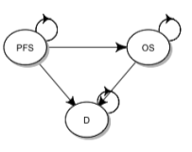

**Figure 1: 3 State Markov model**

**Patients and Treatment Regimens**

The ANGIOPREDICT consortium retrospectively collected tumour biopsies and clinical data from mCRC patients. Patients with advanced (locally irresectable or metastatic) colorectal cancer who began treatment with chemotherapy and Bevacizumab between July 2004 and April 2012 were included in this study. The inclusion criteria was a histologically proven disease diagnosis and combination chemotherapy with Bevacizumab. Tumour tissue from mCRC patients fulfilling these criteria was gathered from the tissue biobanks of the Royal College of Surgeons in Ireland (RCSI) Beaumont Hospital (n = 29), the University of Heidelberg (UHEI), Germany (n = 107) and the VU University Medical Center (VUMC) in The Netherlands (n = 34). Additionally, DNA was extracted from mCRC tumours collected from the CAIRO3 trial, which treated mCRC patients with chemotherapy alone without Bevacizumab and has been described previously [TOL, 2009]. The gender breakdown between trials was comparable (61% male ANGIOPREDICT, 62% male CAIRO3), as was the age (42% >65 in ANGIOPREDICT, 44% > 65 in CAIRO3) T-classification (64% classified as 3 in ANGIOPREDICT, 69% classified as 3 in CAIRO3) and N-classification (34% as 2 in ANGIOPREDICT, 32% as 2 in CAIRO3).

Pathologists assessed tissue samples, and clinical data (including grading, staging, treatment follow-up, age and sex) was gathered from patients' records. PFS and OS were chosen as clinical endpoints. PFS was defined as the time from beginning combination therapy with/without Bevacizumab to progressive disease or any cause of mortality. Patients who withdrew from bevacizumab therapy for reasons other than these were censored on withdrawal. OS was defined as the time beginning therapy with/without Bevacizumab to any cause of mortality. Patient data were administratively censored after 60 months. Informed patient consent and institutional review board approval were obtained in each study centre.[1]

In total, 185 mCRC patients received Bevacizumab combined with chemotherapy (Angiopredict), and 224 mCRC patients received chemotherapy alone (19 Angiopredict patients, 205 CAIRO phase 3 trial patients (NCT00312000)). Multivariate Cox regression revealed that patients with chromosomal instability exhibited an improved response to Bevacizumab and chemotherapy relative to receiving chemotherapy alone. Bevacizumab significantly improved progression-free survival (HR = 0.68; P = 0.00249; 95% CI 0.53--0.87) and overall survival (HR = 0.65; P = 0.00227; 95% CI 0.49−0.86). The analysis was corrected for various potential confounders, and the relationship between chromosomal instability and response to Bevacizumab remained unchanged [@smeets2018].

In the ANGIOPREDICT analysis, patients received a fluoropyrimidine (FP) chemotherapy backbone in combination with either irinotecan (IRI) or oxaliplatin (OX). Consequently, based on standard clinical practice, we considered two lines of treatment with different utilities and costs in each line. The current first-line standard of care for mCRC is FOLFOX, given with or without Bevacizumab. Patients who progress on first-line therapy typically receive second-line treatment with 5-FU, leucovorin, and irinotecan (FOLFIRI) [@tournigand2004]. However, FOLFOX and FOLFIRI can be used interchangeably in the first- and second-line care sequence because phase III trials comparing the two regimens have demonstrated that both provide similar response rates and PFS [Tournigand2004]. Our state-transition model evaluated two different treatment strategies for cost-effectiveness. First-line treatment with FOLFOX and second-line treatment with FOLFIRI, the comparator consisted of the first-line addition of Bevacizumab to FOLFOX, then FOLFIRI on progression. After initiating the second-line treatment, patients subsequently experienced progression until death [Saltz2008].

**Progression Risk, Adverse Events and Mortality:**

We used the data informing the ANGIOPREDICT study to estimate the clinical course for patients treated under standard of care and the hazard ratio results published in this study to estimate outcomes for patients under novel therapy [@smeets2018]. For the purpose of model validation, we replicate the exact PFS and OS curves published in ANGIOPREDICT in our own study (Appendix Figure A1) and demonstrate that the PFS and OS curves generated by the Markov model simulation similarly correspond to those presented in ANGIOPREDICT (Appendix Figure A2).

Data points were used to fit parametric survival models. To produce estimates of progression and mortality matching those reported in ANGIOPREDICT, parametric models were fit to several distributions. This included exponential, Weibull, Gompertz, generalised gamma log-normal and log-logistic. Statistical analyses demonstrated a good fit was provided for both PFS and OS curves by Weibull models, according to the Akaike information criterion (AIC) and visual inspection of the relative conformity of parametric models to the original Kaplan-Meier survival curves (Table A1 in the appendix, Figure A3 in the appendix). Weibull models have been demonstrated to be more suitable for modelling events occurring in mCRC [@goldstein2014a], and support the application of proportional hazard models [@guan2021]. Hence, the Weibull distribution model was chosen for this analysis, and we estimated the transition probabilities for each cycle based on the fitted Weibull survival models.

For standard of care, the transition from first to second-line treatment in each cycle was calculated from the ANGIOPREDICT PFS data; OS data informed transitions from first-line treatment to death. Calculations were based on the [@wang2020] formulation: 1−exp($λ[t−1]^{γ}$ − $λt^{γ}$), where the current stage in the model is t, and λ and γ are the estimated scale and shape parameters respectively. The transition probability of second-line treatment into death is as informed by [@wen2016]. The hazard ratios published in this study were then applied to adjust transition probabilities given the addition of Bevacizumab to chemotherapy. The frequency of adverse events was as described in the TREE trial of FOLFOX with or without Bevacizumab [@hochster2008].

**Utility Estimates**

To present health outcomes in terms of QALYS, we adjusted survival time by quality of life using a Health-Related Quality of Life (HR-QOL) score on a 0-1 utility scale. The quality of life utilities of a cycle spent in each of the model health states have been estimated to be 0.85 for the first-line health state and 0.65 for the second-line health state in the published literature on mCRC patients [@ramsey2000]. Adverse events (AEs) can reduce patients' utility. Most commonly in mCRC this includes grade 3/4 leukopenia, diarrhoea and nausea [@nebuloni2013]. As weighted by the incidence reported in the literature, duration-adjusted AE disutility was subtracted from the baseline utility to determine the total utility of each health state [@guan2021] [@goldstein2015] [@refaat2014].[2] The disutility and duration of such events were derived from the literature [@aballéa2007].[3]

**Cost Estimates:**

Country-specific cost data associated with each health state were gathered via a direct survey of consortium hospitals in the countries studied and previously published studies. All cost estimates were in 2022 Euro values, costs derived from the literature were inflation-adjusted as necessary using appropriate consumer price indices for health [Spain Inflation Calculator: World Bank data, 1955-2022 (EUR) https://www.officialdata.org/spain/inflation, Germany Inflation Calculator: World Bank data, 1956-2022 (EUR) https://www.officialdata.org/germany/inflation][4] From a payer perspective, direct healthcare costs were considered. Costs of both first-line and second-line treatments were included. As informed by previous studies, the primary cost inputs chosen included drug regimen costs, administration costs, and treatment-related adverse event costs per patient, per cycle [@goldstein2017], [@peng2020]. The probability of each AE, and its corresponding duration, were used to calculate the overall effect on costs associated with each treatment. Interventions are considered cost-effective if the ICER is below the thresholds healthcare systems are willing to pay per QALY. The commonly accepted threshold of efficiency is €45,000 per QALY gained in Ireland [O'Mahony2015] and €30,000 per QALY gained in Spain [rivera2017]. There is a lack of formal German thresholds. To contextualise the analysis, a threshold of €78,871 is applied, as suggested by a recent assessment of the monetary value of health in this country [himmler2021].

**Sensitivity Analysis:**

A number of analyses were conducted to evaluate the robustness of the model results to variations in parameters or assumptions. We applied deterministic methods (point estimates with an appropriate range) and probabilistic methods (parameterised distributions) to conduct a sensitivity analysis of our results. The baseline values, ranges, and distributions used for model parameters in these analyses are presented in Table 1.

In the deterministic sensitivity analysis, we evaluated the influence of varying each parameter individually on the cost-effectiveness results. Assumptions for defining the interval estimates for this univariate analysis came from the literature. Wherever possible, these were taken directly from the estimation process, with confidence intervals or standard errors extracted from published sources to generate a plausible range for the probabilities, adverse events, costs and utilities. Where this information was unavailable, model inputs varied 20% above and below base case values, as is standard practice [@goldstein2014a; @goulart2011]. To study the influence of a range of transition risks, the PFS and OS curves $S(t)$ in the model were altered for both treatment strategies via a hazard ratio adjustment $\gamma$, as $[S(t)^{\gamma}]$. Subsequently, transition risks for each cycle were calculated from these adjusted survival curves in the deterministic sensitivity analysis [@goldstein2014a]. The adjustment hazard ratio was 1 +/- 0.2, i.e., the base case varied within plus or minus 20%.

We conducted a probabilistic sensitivity analysis (PSA) to determine the consequences of parameter uncertainty in our model for cost-effectiveness outcomes. Simultaneous samples were drawn from model parameters in Monte Carlo simulations according to their sampling distributions, reflecting any uncertainty in parameter estimates in the evidence. Thus, joint uncertainty was propagated through the model over 10,000 replications, providing a comprehensive assessment of model parameter uncertainty. The distribution for parameters was specified in the probabilistic analysis per standard statistical methods. Beta distributions were applied to binomial data; Gamma distributions were applied to right-skewed parameters; the log-normal distribution was applied to hazard ratios; a multivariate normal distribution was applied to the Weibull parametric survival distribution, and the uniform distribution was applied to the discount rate, with all distributions applied directly in the PSA [@briggs2012a].[5]

*Table 1 Model Parameters Values: Baseline, Ranges and Distributions for Sensitivity Analysis*

| **Parameter** | **Base Case Value** | **Minimum Value** | **Maximum Value** | **Source** | **Distribution** |
| --- | --- | --- | --- | --- | --- |
| **Cost (Per Cycle)** |  |  |  | *Where data is drawn from the literature, the source is described below.* |  |
| FOLFOX | **ESP:** 285.54  **DE:** 1276.66  **IRE:**  307.81 | **ESP:**  228.432  **DE:**  1021.328  **IRE:**  246.248 | **ESP:**  342.648  **DE:**  1531.99  **IRE:**  369.372 | **ESP:** [Rivera2007] | Gamma  **ESP:** A,B(100, 2.8554)  **DE:** A,B(100, 12.77)  **IRE:** A,B(100, 3.078) |
| FOLFIRI | **ESP:** 139.58  **DE:** 1309.64  **IRE:**  326.02 | **ESP:**  111.664  **DE:**  1047.712  **IRE:**  260.82 | **ESP:**  167.496  **DE:**  1571.568  **IRE:**  391.22 | **ESP:** [Rivera2007] | Gamma  **ESP:** A,B(100, 1.3958)  **DE:** A,B(100, 13.1)  **IRE:** A,B( 100, 3.26) |
| Bevacizumab | **ESP:** 1325.87  **DE:** 2952.24  **IRE:**  2580.38 | **ESP:**  1060.696  **DE:**  2361.792  **IRE:**  2064.30 | **ESP:**  1591.044  **DE:**  3542.688  **IRE:**  3096.46 | **ESP:** [Rivera2007] | Gamma  **ESP:** A,B(100,13.2587)  **DE:** A,B(100, 29.52)  **IRE:** A,B(100,25.8) |
| Administration Cost | **ESP:** 314.94  **DE:** 1794.40  **IRE:**  365 | **ESP:**  251.952  **DE:**  1435.52  **IRE:**  292 | **ESP:**  377.928  **DE:**  2153.28  **IRE:**  438 | Gamma  **ESP:** [Rivera2007]  **DE:**  [ Goerner] | Gamma  **ESP:** A,B(100,3.1494)  **DE:** A,B( 100, 17.94)  **IRE:** A,B(100,3.65) |
| **Adverse Event Cost** |  |  |  |  |  |
| Leukopenia | **ESP:** 4885.95  **DE:**  3837  **IRE:**  2835.89 | **ESP:**  3908.76  **DE:**  3069.6  **IRE:**  2268.71 | **ESP:**  5863.14  **DE:**  4604.4  **IRE:**  3403.07 | **ESP:**  [Mayordomo2009]  **DE:**  [Butzke2016] | Gamma  **ESP:** A,B(100, 48.8595)  **DE:** A,B( 100, 38.37)  **IRE:** A,B(100,28.36) |
| Diarrhea | **ESP:** - 507.36  **DE:**  1816.37  **IRE:**  1458.80 | **ESP:**  405.888  **DE:**  1453.096  **IRE:**  1167.04 | **ESP:**  608.832  **DE:**  2179.644  **IRE:**  1750.56 | **ESP:**  [Asensio2013]  **DE:** [Butzke2016] | Gamma  **ESP:** A,B(100, 5.0736)  **DE:** A,B( 100, 18.16)  **IRE:** A,B(100, 14.59) |
| Nausea | **ESP:** 95.03  **DE:**  526.70  **IRE:**  409.03 | **ESP:**  76.024  **DE:**  421.36  **IRE:**  327.22 | **ESP:**  114.036  **DE:**  632.04  **IRE:**  490.84 | **ESP:** [Nilsson2021]  **DE:**  [Ihbe-Heffinger2004] | Gamma  **ESP:** A,B(100, 0.9503)  **DE:** A,B( 100, 5.267)  **IRE:** A,B(100,4.09) |
|  |  |  |  |  |  |
| **Adverse Event Incidence - With Bevacizumab** |  |  |  |  |  |
| Leukopenia | 0.07 | 0.056 | 0.084 | [Hochster2008] | Beta  A,B(92.93,1235) |
| Diarrhea | 0.11 | 0.088 | 0.132 | [Hochster2008] | Beta  A,B(88.89, 719.20) |
| Nausea | 0.07 | 0.056 | 0.084 | [Hochster2008] | Beta  A,B( 92.93, 1235) |
| **Adverse Event Incidence - Without Bevacizumab** |  |  |  |  |  |
| Leukopenia | 0.04 | 0.032 | 0.048 | [Hochster2008] | Beta  A,B( 95.96, 2303) |
| Diarrhea | 0.31 | 0.248 | 0.372 | [Hochster2008] | Beta  A,B( 68.69, 152.90 ) |
| Nausea | 0.31 | 0.248 | 0.372 | [Hochster2008] | Beta  A,B( 68.69, 152.90) |
| **Utility (Per Cycle)** |  |  |  |  |  |
| Progression Free Survival | 0.850 | 0.68 | 1 | [@ramsey2000] | Beta  A,B( 15.41, 2.72) |
| Overall Survival | 0.650 | 0.52 | 0.78 | [@ramsey2000] | Beta  A,B( 32.96, 17.75) |
| **Adverse Event Disutility** |  |  |  |  |  |
| Leukopenia | 0.45 | 0.36 | 0.54 | [Aballéa2007] | Beta  A,B( 54.55, 66.67) |
| Diarrhea | 0.19 | 0.152 | 0.228 | [Aballéa2007] | Beta  A,B( 80.81, 344.5) |
| Vomiting | 0.36 | 0.288 | 0.432 | [Aballéa2007] | Beta  A,B( 63.64, 113.1) |
| **Hazard Ratios** |  |  |  |  |  |
| PFS to OS under the Experimental Strategy | 0.68 | 0.53 | 0.87 | [Smeets2018] | lnorm() |
| PFS to Dead under the Experimental Strategy | 0.65 | 0.49 | 0.86 | [Smeets et al. 2018] | lnorm() |
| Probability of Dying under Second-Line Treatment | 0.17 | 0.12 | 0.22 | [Wen2016] | Beta  A,B( 36.69, 179.1) |
| **Discount Rate** |  |  |  |  |  |
| Costs | 0.04 | 0 | 0.08 |  | Uniform(0.00,0.08) |
| Outcomes | 0.04 | 0 | 0.08 |  | Uniform(0.00,0.08) |

**RESULTS:**

We compared the effectiveness and costs of chemotherapy with and without the addition of Bevacizumab in the base case analysis. In Germany, Ireland and Spain, the addition of Bevacizumab to therapy provided 0.646 QALYS at a cost of €149,699.48, €78,860.21, and €50,539.94 respectively. Standard of care (FOLFOX without Bevacizumab) provided 0.335 QALYS at a cost of €76,365.86, €24,703.48, and €17,591.16 respectively in these same countries. In terms of life years (LYs), the addition of Bevacizumab provided identical 1.00 LYs in each country compared with chemotherapy alone which provided 0.79 LYs. Thus, in Ireland, Germany and Spain, the addition of Bevacizumab to therapy provided an improvement in life expectancy of 73 days. The highest ICER was in Germany (€235,404.5/QALY), while the lowest was in Spain (€105,767.2/QALY). In Ireland, the ICER was €173,845.8 per QALY. All values are significantly higher than currently accepted WTP thresholds in these countries, and all results are summarised in Table 2.

|  |
| --- |
| Table 2. Base case results |
| Result | Germany | Ireland | Spain |
| Total incremental cost (Euros) | 73,333.61 | 54,156.73 | 32,948.78 |
| Total incremental effect (QALYs) | 0.312 | 0.312 | 0.312 |
| ICER (Euros/QALY) | 235,404.50 | 173,845.80 | 105,767.20 |

We evaluated the relative weight of each parameter individually in our model on the overall uncertainty of cost-effectiveness in a one-way sensitivity analysis [@hamdyelsisi2019]. In Figure 2, we create a tornado plot of this one-way sensitivity analysis to describe which parameters are driving the majority of the variation in the outcome. In this diagram, "Parameter Level High/Low" correspond to parameter values above or below the median point estimates reported in Table 1 to highlight where differences in the magnitude of input values (across the minimum and maximum values described in Table 1) result in changes in the expected outcome value.

Across the univariate analyses, parameters that influenced ICERs were comparable across countries. The most significant influence on the ICER consistently came from the level of utility in the first-line health state and the cost of Bevacizumab. This is not unexpected given that Bevacizumab is ten times larger than any other included treatment cost in Ireland and Spain and three times larger in Germany. The significance of utility in the first-line health state is also not surprising, given that the mechanism of action in Bevacizumab is to keep patients in the first-line health state for as long as possible. Within a relatively narrow range, there was a limited influence of variation in other parameters on the ICER. Results remained robust to adjustments, with an ICER consistently above the threshold of WTP per QALY in the countries studied across parameter values.

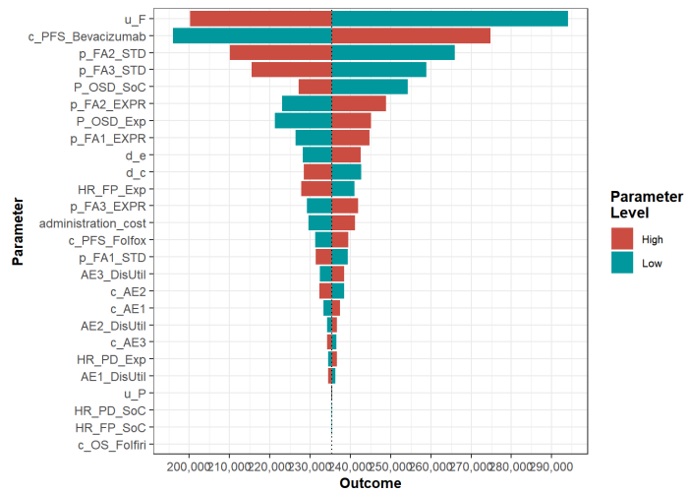

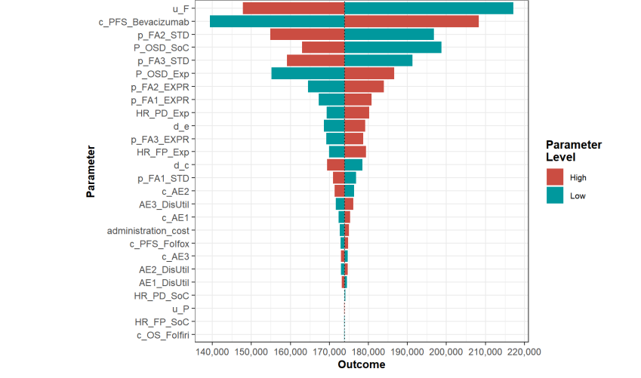

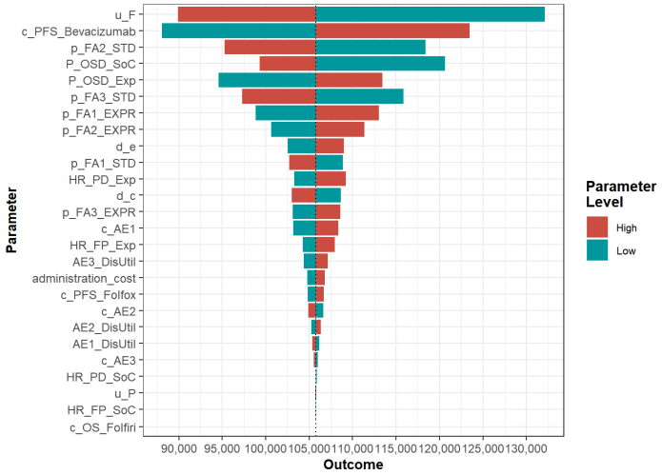

**Figure 2: Tornado Plot: Germany, Ireland and Spain**

While a tornado plot provides a useful visual aid to identify which individual parameters are driving the majority of the variation in the outcome of interest, varying individual parameters while fixing all others at their base case understates uncertainty, as in reality, parameters do not vary in isolation. To jointly propagate uncertainty throughout the model, we assigned distributions to any parameters not estimated with certainty. We considered whether values within a plausible range for input parameter alter the conclusions of cost-effectiveness drawn from the original analysis. In the PSA, we computed model outcomes (total discounted costs and QALYs) for the experimental strategy and standard of care for each sampled set of parameter values in Table 1. Probabilistic results were remarkably similar to the deterministic analysis, per Table 3, demonstrating the robustness of the model.

The results of the probabilistic sensitivity analysis are illustrated in the cost-effectiveness scatter plot in Figure 3. This illustrates the distribution of costs and effects for treatment with and without Bevacizumab. We randomly sampled from each specified parameter distribution in the probabilistic analysis, calculating the expected costs and effects of that combination of parameter values. Each point in this plot represents a single sample of parameter values. In total, 10,000 replications were completed to determine the possible distribution of the resulting costs and effects with and without Bevacizumab. The ellipses around points represent 95% confidence incidences. Figure 3 demonstrates a greater degree of uncertainty surrounding the mean point estimates for the addition of Bevacizumab to the standard of care, illustrated by the magnitude of the 95%-confidence ellipses surrounding these estimates. Per Figure 2, this is likely a consequence of the leverage Bevacizumab has in affecting the model outcome, both in terms of cost and effectiveness. However, no ICER value is sufficiently close to the WTP threshold to be considered cost-effective, regardless of the country under study.

We derived cost-effectiveness acceptability curves (CEACs) from the probabilistic sensitivity analysis. The results are shown in Figure 4. This describes the probability that the addition of Bevacizumab was cost-effective across increasing WTP values. Results demonstrate that for the addition of Bevacizumab to be considered cost-effective in the countries studied, the WTP thresholds would have to increase to many times their current value, often three to five times currently accepted levels.

|  |
| --- |
| Table 3. Probabilistic Sensitivity Analysis |
| Result | Germany | Ireland | Spain |
| Total incremental cost (Euros) | 73,367 | 54,214 | 32,977 |
| Total incremental effect (QALYs) | 0.312 | 0.312 | 0.312 |
| ICER (Euros/QALY) | 235,076 | 173,707 | 105,663 |

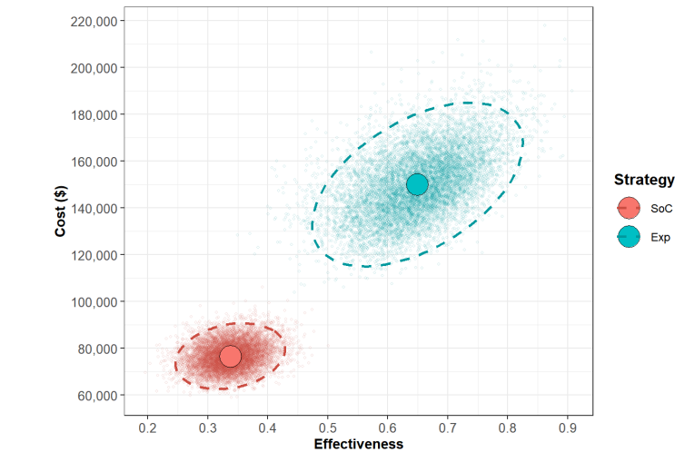

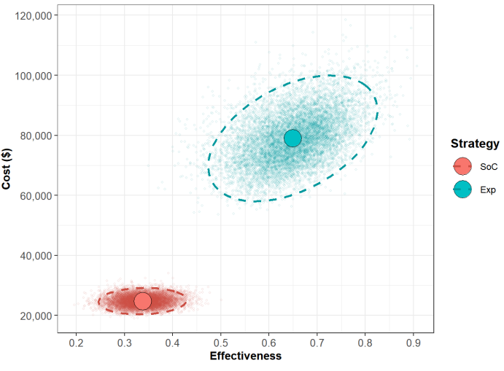

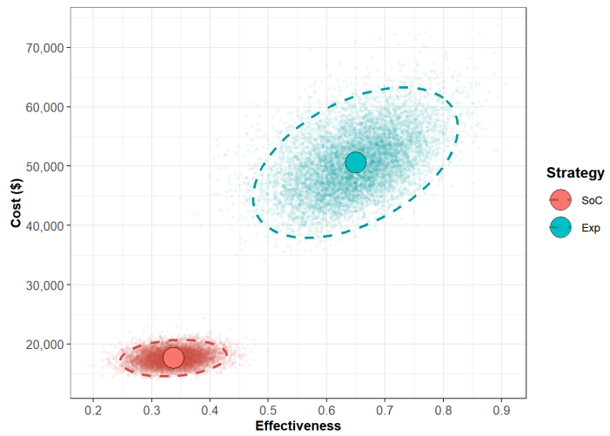

**Figure 3: Cost-effectiveness Scatter Plot: Germany, Ireland and Spain** **(n = 10,000)**

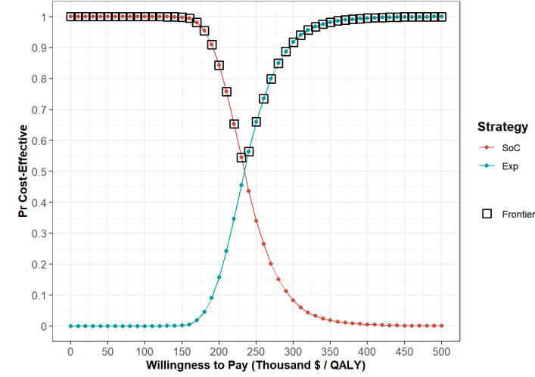

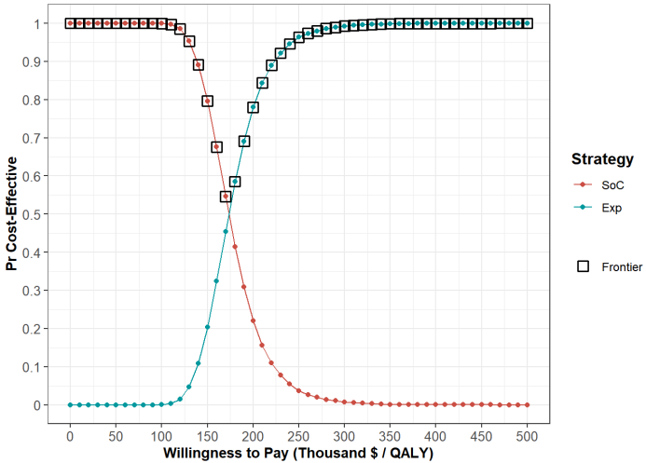

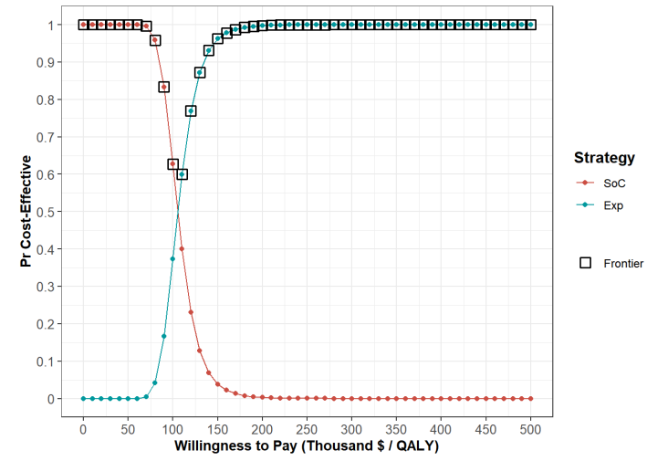

**Figure 4** **Cost-Effectiveness Acceptability Curves (CEACs):Germany, Ireland and Spain**

**DISCUSSION:**

Greater than 5 million people are estimated to be living with CRC worldwide [@vabi2021]. Consequently, although urgently required, expansion to treatment options for mCRC can be expected to impact healthcare costs significantly. At the same time, because healthcare resources are finite, investments in one area of the healthcare system are necessarily at the expense of others. Against this background of increased demands on finite resources, the financial characteristics of emerging therapies are quickly becoming a critical consideration in clinical decision-making. Thus, for novel cancer therapy to constitute a useful addition to care, it must be both an effective and efficient use of constrained resources. Where this is not the case, providing additional care in one area of the health system might require contracting the provision of care in others in a manner which leads to a net loss, rather than gain, in the total health produced.

ANGIOPREDICT demonstrated a level of benefit when Bevacizumab was added to a chemotherapy backbone that surpassed that seen previously in treatment [Hurwitz2004] [Saltz2008]. We hypothesised that this improved efficacy may consequently increase efficiency, such that Bevacizumab may finally reach a reasonable cost-per-QALY threshold to be deemed cost-effective. It would then be possible to determine that the gains from introducing this intervention now outweigh those foregone when reallocating existing health budgets, thus facilitating optimal decision-making by maximising the expected overall benefits from available resources in the health care system.

The challenge to drawing compelling conclusions from such an analysis is the heterogeneity of treatment costs between countries and differences in what is considered an acceptable threshold for cost per QALY. It is not possible to simply extrapolate cost-effectiveness data globally. In response to such concerns, we evaluated the cost-effectiveness of Bevacizumab in the first-line treatment of metastatic colorectal cancer (mCRC) for those patients with chromosomal instability described by the ANGIOPREDICT consortium from the perspective of payers across three selected countries, namely Germany, Ireland and Spain. Current health expenditure in Germany is the largest share of gross domestic product (GDP) of all 27 EU Member States [@destatisstatistischesbundesamt], while health spending in Spain is below the EU average [@europeanobservatoryonhealth2019]. Ireland's public health spending has historically been low but has increased dramatically over the past half-century, quadrupling as a percentage of national income [@casey].

While health improvements warrant increased demands on healthcare services, treatment with Bevacizumab continues to provide minimal incremental benefit at a high incremental cost per QALY, even in this particularly responsive patient group. This result is consistent across variability in pricing, healthcare costs, willingness to pay thresholds and multiple international payers. While the cost-effectiveness of this treatment strategy for additional countries remains to be discovered, our application of this model to countries with a mixed health expenditure profile suggests it is unlikely that other EU member states would derive a significantly more optimal value for money.

Our study does have some other limitations. In particular, we assess cost-effectiveness for an originator drug at a time of increased approval of biosimilar therapeutics. This is particularly likely in Europe when one considers that biological treatments account for almost a third of all pharmaceutical spending [Troein2020]. The provision of such pharmaceutical options may suggest an alternative that would make our analysis cost-effective. That is, perhaps health systems could reduce their expenditure while maintaining a therapy that sustains the safety and efficacy of Bevacizumab.

Available therapeutic options with clinical profiles most similar to that of the originator are Zirabev (Pfizer), MVASI (Amgen) and Aybintio (MSD) [Bachu2022]. The proposed reductions in price for these biosimilars are typically a maximum decrease of 30% [Yang2021]. We calculate that a reduction in the cost of Bevacizumab of 80%, 75% and 74% would be necessary to make the treatment strategy assessed cost-effective at the WTP thresholds of Germany, Ireland and Spain. Thus we believe that the introduction of biosimilars as currently described would not generate sufficient cost savings in the health systems under study to alter the conclusions of our analysis.

The ICER values we report may appear excessively large. However, our results are consistent with the results of a global cost-effectiveness analysis of first-line Bevacizumab in patients without chromosomal instability. This analysis reported an ICER of between $278,000–$358,000 per QALY gained in the U.K., Australia, Israel, and Canada. In the U.S., the ICER was $571,000 per QALY gained [Goldstein2017]. This result is not uncommon in biological treatments. For example, Cetuximab is an epidermal growth factor receptor (EGFR) inhibitor with a recent cost-effectiveness analysis reporting an ICER of $268,094, driven entirely by the price of Cetuximab [Wong2019]. Like our analysis, the study authors also find that the magnitude of clinical benefit does not offset the additional cost of the biological treatment. A similar study reported an ICER of $3.2 million for the first-line use of an Epidermal Growth Factor Receptor Inhibitor in mCRC [Riesco-Martínez2016]. Biologics may simply be too expensive compared with standard chemotherapy when considering the benefit that they provide.

In Germany, the practical value of our analysis for decision makers needs to be clarified. The German statutory authority that assesses the degree of benefit of emerging therapies, the Federal Joint Committee (GBA), applies an assortment of methodologies for assessing cost-effectiveness when making reimbursement decisions [Sieg2020]. These methods may not incorporate those techniques applied in this analysis. However, by providing detailed information on input parameters and reporting ICERs directly, we contribute data that will doubtless support any such analysis conducted by the GBA.

Finally, we developed our model applying data from the ANGIOPREDICT study, subsequently, it may not exhaustively reflect the real-world experience of a population of patients. However, the ranges we apply across various sensitivity analyses will likely account for variations between populations. Our sensitivity analysis will similarly account for any possible variations in true utility values as a product of applying utility data in our study from an external source, per common practice in health economic analysis [Goldstein2015]. Variations in cost are similarly subsumed in the ranges and distributions applied across sensitivity analyses.

**CONCLUSIONS:**

While Bevacizumab has demonstrated improvements in patient outcomes, without analogous improvements in efficiency we cannot conclude that the expected benefits of care outweigh the expected costs in Germany, Ireland or Spain.

**Appendix:**

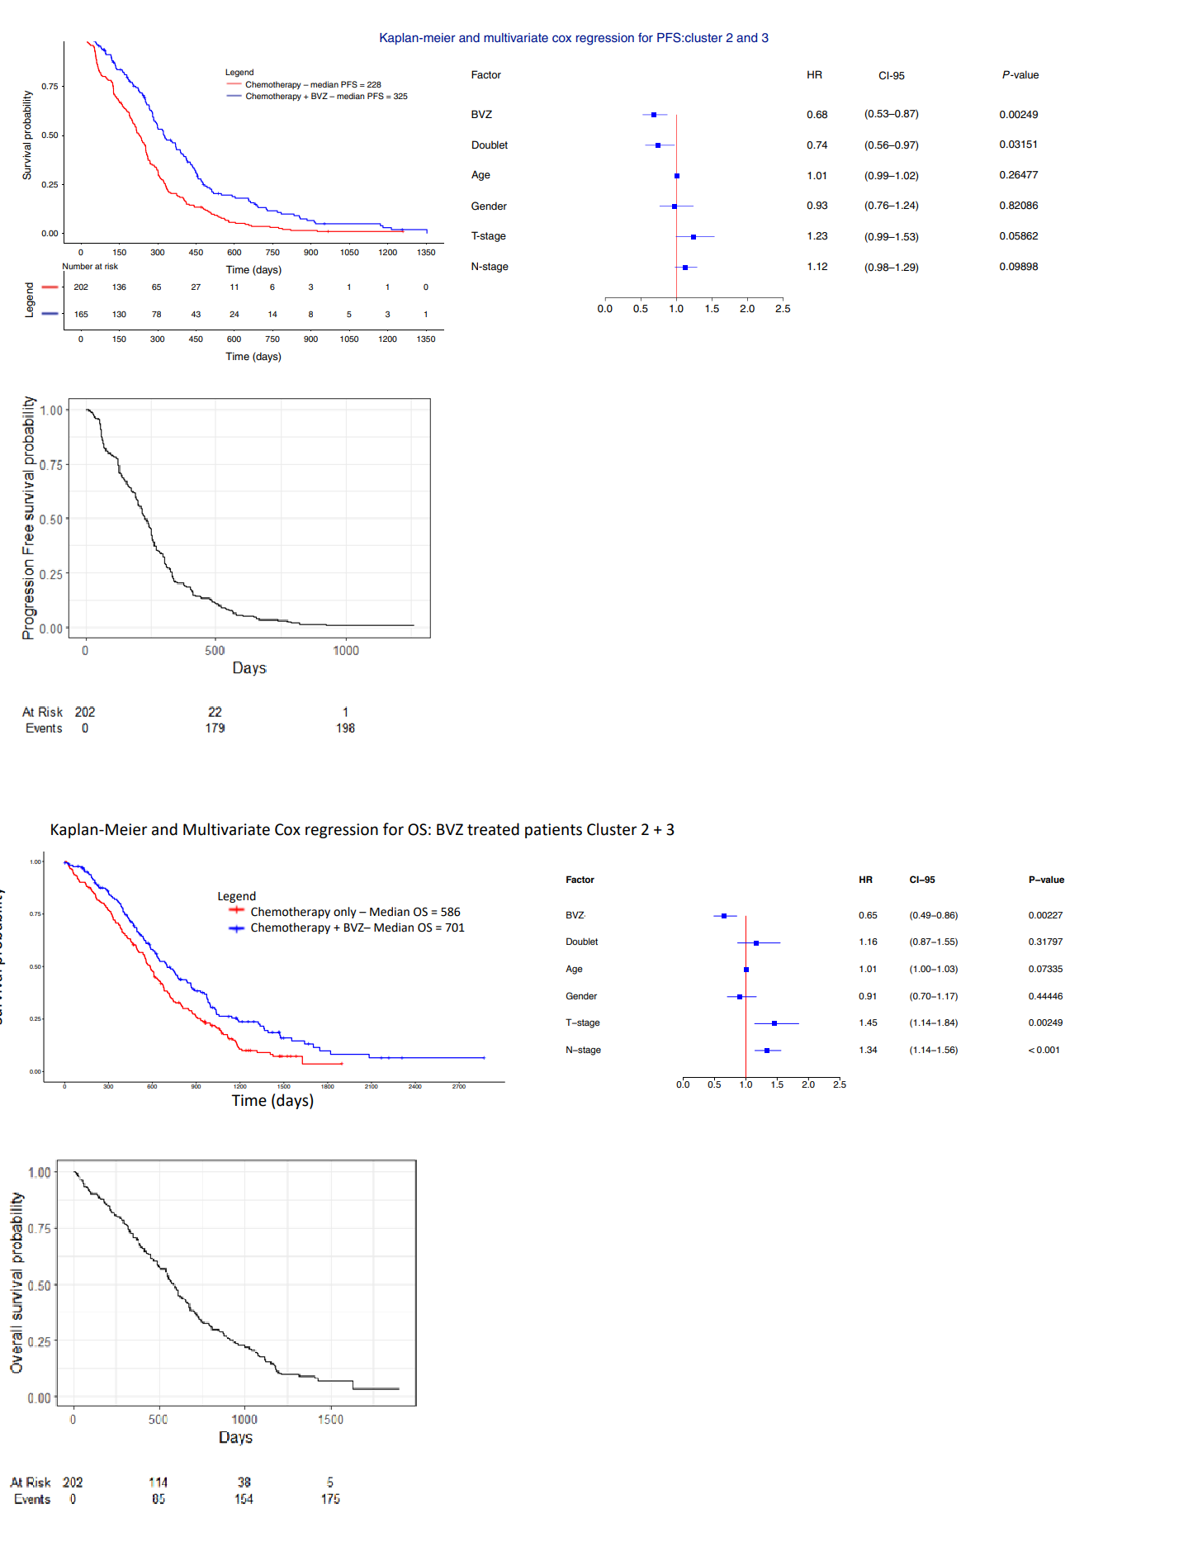

**Figure A1**

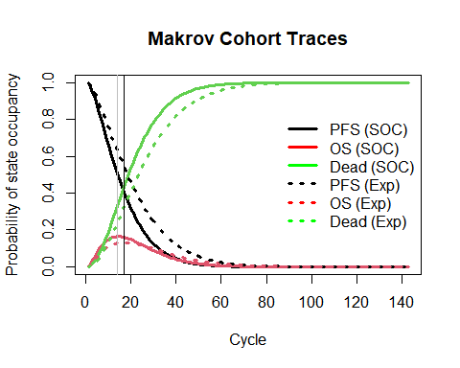

**Figure A2**

|  |  |  |  |  |  |  |
| --- | --- | --- | --- | --- | --- | --- |
| **Distribution** | Exponential | Gamma | Gompertz | Log-logistic | Log-normal | Weibull |
| Time-to-progression | 2604.383 | 2570.365 | 2594.880 | 2579.625 | 2580.161 | 2574.970 |
| Time-to-dead | 2664.472 | 2648.915 | 2648.350 | 2665.054 | 2680.234 | 2646.087 |

**Table A1**

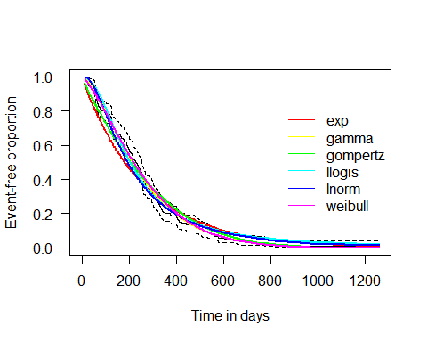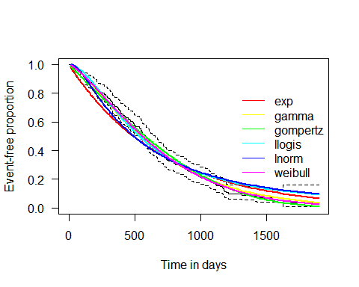

**Figure A3**

**References:**

Aballéa, Samuel, Jeremy V. M. Chancellor, Maria Raikou, Michael F. Drummond, Milton C. Weinstein, Sophia Jourdan, and John Bridgewater.

2007. “Cost-Effectiveness Analysis of Oxaliplatin Compared with 5-Fluorouracil/Leucovorin in Adjuvant Treatment of Stage III Colon Cancer in

the US.” Cancer 109 (6): 1082–89. https://doi.org/10.1002/cncr.22512 (https://doi.org/10.1002/cncr.22512).

Alarid-Escudero, Fernando, Eline M. Krijkamp, Eva A. Enns, Alan Yang, M. G. Myriam Hunink, Petros Pechlivanoglou, and Hawre Jalal. 2021. “An

Introductory Tutorial on Cohort State-Transition Models in r Using a Cost-Effectiveness Analysis Example.” arXiv:2001.07824 [q-Bio, Stat],

August. http://arxiv.org/abs/2001.07824 (http://arxiv.org/abs/2001.07824).

Briggs, Andrew H., Milton C. Weinstein, Elisabeth AL Fenwick, Jonathan Karnon, Mark J. Sculpher, and A. David Paltiel. 2012. “Model Parameter

Estimation and Uncertainty Analysis: A Report of the ISPOR-SMDM Modeling Good Research Practices Task Force Working Group6.” Medical

Decision Making 32 (5): 722732.

Franken, M. D., E. M. van Rooijen, A. M. May, H. Koffijberg, H. van Tinteren, L. Mol, A. J. ten Tije, et al. 2017. “Cost-Effectiveness of Capecitabine

and Bevacizumab Maintenance Treatment After First-Line Induction Treatment in Metastatic Colorectal Cancer.” European Journal of Cancer

75 (April): 204–12. https://doi.org/10.1016/j.ejca.2017.01.019 (https://doi.org/10.1016/j.ejca.2017.01.019).

Goldstein, Daniel A., Bilal B. Ahmad, Qiushi Chen, Turgay Ayer, David H. Howard, Joseph Lipscomb, Bassel F. El-Rayes, and Christopher R.

Flowers. 2015. “Cost-Effectiveness Analysis of Regorafenib for Metastatic Colorectal Cancer.” Journal of Clinical Oncology: Official Journal of

the American Society of Clinical Oncology 33 (32): 3727–32. https://doi.org/10.1200/JCO.2015.61.9569

(https://doi.org/10.1200/JCO.2015.61.9569).

Goldstein, Daniel A., Qiushi Chen, Turgay Ayer, David H. Howard, Joseph Lipscomb, Bassel F. El-Rayes, and Christopher R. Flowers. 2015a.

“First-and Second-Line Bevacizumab in Addition to Chemotherapy for Metastatic Colorectal Cancer: A United Statesbased Cost-Effectiveness

Analysis.” Journal of Clinical Oncology 33 (10): 1112.

———. 2015b. “First- and Second-Line Bevacizumab in Addition to Chemotherapy for Metastatic Colorectal Cancer: A United Statesbased CostEffectiveness Analysis.” Journal of Clinical Oncology 33 (10): 1112–18. https://doi.org/10.1200/JCO.2014.58.4904

(https://doi.org/10.1200/JCO.2014.58.4904).

Goldstein, Daniel A., Qiushi Chen, Turgay Ayer, David H. Howard, Joseph Lipscomb, R. Donald Harvey, Bassel F. El-Rayes, and Christopher R.

Flowers. 2014a. “Cost Effectiveness Analysis of Pharmacokinetically-Guided 5-Fluorouracil in FOLFOX Chemotherapy for Metastatic Colorectal

Cancer.” Clinical Colorectal Cancer 13 (4): 219–25. https://doi.org/10.1016/j.clcc.2014.09.007 (https://doi.org/10.1016/j.clcc.2014.09.007).

———. 2014b. “Cost Effectiveness Analysis of Pharmacokinetically-Guided 5-Fluorouracil in FOLFOX Chemotherapy for Metastatic Colorectal

Cancer.” Clinical Colorectal Cancer 13 (4): 219–25. https://doi.org/10.1016/j.clcc.2014.09.007 (https://doi.org/10.1016/j.clcc.2014.09.007).

Goldstein, Daniel A., Qiushi Chen, Turgay Ayer, David H. Howard, Joseph Lipscomb, Suresh S. Ramalingam, Fadlo R. Khuri, and Christopher R.

Flowers. 2015. “Necitumumab in Metastatic Squamous Cell Lung Cancer: Establishing a Value-Based Cost.” JAMA Oncology 1 (9): 12931300.

Goulart, Bernardo, and Scott Ramsey. 2011b. “A Trial-Based Assessment of the Cost-Utility of Bevacizumab and Chemotherapy Versus

Chemotherapy Alone for Advanced Non-Small Cell Lung Cancer.” Value in Health 14 (6): 836–45. https://doi.org/10.1016/j.jval.2011.04.004

(https://doi.org/10.1016/j.jval.2011.04.004). ———. 2011a. “A Trial-Based Assessment of the Cost-Utility of Bevacizumab and Chemotherapy Versus Chemotherapy Alone for Advanced NonSmall Cell Lung Cancer.” Value in Health 14 (6): 836–45. https://doi.org/10.1016/j.jval.2011.04.004 (https://doi.org/10.1016/j.jval.2011.04.004).

Guan, Xin, Hongchao Li, Xiaomo Xiong, Cike Peng, Ning Wang, Xiao Ma, and Aixia Ma. 2021. “Cost-Effectiveness Analysis of Fruquintinib Versus

Regorafenib as the Third-Line Therapy for Metastatic Colorectal Cancer in China.” Journal of Medical Economics 24 (1): 339–44.

https://doi.org/10.1080/13696998.2021.1888743 (https://doi.org/10.1080/13696998.2021.1888743).

Hamdy Elsisi, Gihan, Yousery Nada, Noha Rashad, and João Carapinha. 2019. “Cost-Effectiveness of Sorafenib Versus Best Supportive Care in

Advanced Hepatocellular Carcinoma in Egypt.” Journal of Medical Economics 22 (2): 163–68. https://doi.org/10.1080/13696998.2018.1552432

(https://doi.org/10.1080/13696998.2018.1552432).

Hochster, Howard S., Lowell L. Hart, Ramesh K. Ramanathan, Barrett H. Childs, John D. Hainsworth, Allen L. Cohn, Lucas Wong, et al. 2008.

“Safety and Efficacy of Oxaliplatin and Fluoropyrimidine Regimens With or Without Bevacizumab As First-Line Treatment of Metastatic

Colorectal Cancer: Results of the TREE Study.” Journal of Clinical Oncology 26 (21): 3523–29. https://doi.org/10.1200/JCO.2007.15.4138

(https://doi.org/10.1200/JCO.2007.15.4138).

Jalal, Hawre, Petros Pechlivanoglou, Eline Krijkamp, Fernando Alarid-Escudero, Eva Enns, and M. G. Myriam Hunink. 2017. “An Overview of R in

Health Decision Sciences.” Medical Decision Making 37 (7): 735–46. https://doi.org/10.1177/0272989X16686559

(https://doi.org/10.1177/0272989X16686559).

Krijkamp, Eline M., Fernando Alarid-Escudero, Eva A. Enns, Hawre J. Jalal, M. G. Myriam Hunink, and Petros Pechlivanoglou. 2018.

“Microsimulation Modeling for Health Decision Sciences Using R: A Tutorial.” Medical Decision Making 38 (3): 400–422.

https://doi.org/10.1177/0272989X18754513 (https://doi.org/10.1177/0272989X18754513).

Krijkamp, Eline M., Fernando Alarid-Escudero, Eva A. Enns, Petros Pechlivanoglou, M.G. Myriam Hunink, Alan Yang, and Hawre J. Jalal. 2020. “A

Multidimensional Array Representation of State-Transition Model Dynamics.” Medical Decision Making 40 (2): 242–48.

https://doi.org/10.1177/0272989X19893973 (https://doi.org/10.1177/0272989X19893973).

Kristin, Erna, Dwi Endarti, Levina Chandra Khoe, Kartika Widayati Taroeno-Hariadi, Christina Trijayanti, Armansyah Armansyah, and Sudigdo

Sastroasmoro. 2021. “Economic Evaluation of Adding Bevacizumab to Chemotherapy for Metastatic Colorectal Cancer (mCRC) Patients in

Indonesia.” Asian Pacific Journal of Cancer Prevention : APJCP 22 (6): 1921–26. https://doi.org/10.31557/APJCP.2021.22.6.1921

(https://doi.org/10.31557/APJCP.2021.22.6.1921).

Mitchell, Mark. 2022. Engauge Digitizer Version 12.2. Available from: http://digitizer.sourceforge.net (Available from: http://digitizer.sourceforge.net).

Nebuloni, Daniela R., Milena P. Mak, Fabiano Hahn Souza, Daniel F. Saragiotto, Thiago Júlio, Gilberto De Castro Jr, Jorge Sabbaga, and Paulo M.

Hoff. 2013. “Modified FLOX as First-Line Chemotherapy for Metastatic Colorectal Cancer Patients in the Public Health System in Brazil:

Effectiveness and Cost-Utility Analysis.” Molecular and Clinical Oncology 1 (1): 175–79. https://doi.org/10.3892/mco.2012.12

(https://doi.org/10.3892/mco.2012.12).

Nwaokorie, Annabelle, and Dirk Fey. 2021. “Personalised Medicine for Colorectal Cancer Using Mechanism-Based Machine Learning Models.”

International Journal of Molecular Sciences 22 (18): 9970. https://doi.org/10.3390/ijms22189970 (https://doi.org/10.3390/ijms22189970).

Ramsey, Scott D., M. Robyn Andersen, Ruth Etzioni, Carol Moinpour, Sue Peacock, Arnold Potosky, and Nicole Urban. 2000. “Quality of Life in

Survivors of Colorectal Carcinoma.” Cancer 88 (6): 1294–1303. https://doi.org/https://doi.org/10.1002/(SICI)1097-

0142(20000315)88:6<1294::AID-CNCR4>3.0.CO;2-M (https://doi.org/10.1002/(SICI)1097-0142(20000315)88:6<1294::AID-CNCR4>3.0.CO;2-

M).

Refaat, Tamer, Mehee Choi, Germaine Gaber, Krystyna Kiel, Minesh Mehta, William Gradishar, and William Small. 2014. “Markov model and costeffectiveness analysis of bevacizumab in HER2-negative metastatic breast cancer.” American Journal of Clinical Oncology 37 (5): 480–85.

https://doi.org/10.1097/COC.0b013e31827e4e9a (https://doi.org/10.1097/COC.0b013e31827e4e9a).

Shih, Ted, and Celeste Lindley. 2006. “Bevacizumab: An Angiogenesis Inhibitor for the Treatment of Solid Malignancies.” Clinical Therapeutics 28

(11): 1779–1802. https://doi.org/10.1016/j.clinthera.2006.11.015 (https://doi.org/10.1016/j.clinthera.2006.11.015).

Siegel, Rebecca L., Kimberly D. Miller, and Ahmedin Jemal. 2019. “Cancer Statistics, 2019.” CA: A Cancer Journal for Clinicians 69 (1): 734.

Smeets, Dominiek, Ian S. Miller, Darran P. O’Connor, Sudipto Das, Bruce Moran, Bram Boeckx, Timo Gaiser, Johannes Betge, Ana Barat, and Rut

Klinger. 2018. “Copy Number Load Predicts Outcome of Metastatic Colorectal Cancer Patients Receiving Bevacizumab Combination Therapy.”

Nature Communications 9 (1): 116.

Tiwari, Ankita, Shivani Saraf, Amit Verma, Pritish Kumar Panda, and Sanjay K. Jain. 2018. “Novel Targeting Approaches and Signaling Pathways of

Colorectal Cancer: An Insight.” World Journal of Gastroenterology 24 (39): 4428.

Vabi, Benjamin W., John F. Gibbs, and Glenn S. Parker. 2021. “Implications of the Growing Incidence of Global Colorectal Cancer.” Journal of

Gastrointestinal Oncology 12 (Suppl 2): S387–98. https://doi.org/10.21037/jgo-2019-gi-06 (https://doi.org/10.21037/jgo-2019-gi-06).

Wang, Huijuan, Lingfei Huang, Peng Gao, Zhengyi Zhu, Weifeng Ye, Haiying Ding, and Luo Fang. 2020. “Cost-Effectiveness Analysis of

Cetuximab Combined with Chemotherapy as a First-Line Treatment for Patients with RAS Wild-Type Metastatic Colorectal Cancer Based on

the TAILOR Trial.” BMJ Open 10 (2): e030738. https://doi.org/10.1136/bmjopen-2019-030738 (https://doi.org/10.1136/bmjopen-2019-030738).

Wen, Feng, Hanrui Zheng, Yifan Wu, John Wheeler, Xiaoxi Zeng, Ping Fu, and Qiu Li. 2016. “Cost-Effectiveness Analysis of Fluorouracil,

Leucovorin, and Irinotecan Versus Epirubicin, Cisplatin, and Capecitabine in Patients with Advanced Gastric Adenocarcinoma.” Scientific

Reports 6 (1): 36060. https://doi.org/10.1038/srep36060 (https://doi.org/10.1038/srep36060).

1. This cost-effectiveness analysis was a secondary data analysis and did not directly involve patients. Extensive detail on the original study has been reported previously [@sturrock2018]}
2. Assuming the duration of each AE was 7 days.
3. We do not model AEs for second-line therapy. Because all patients are identically treated with FOLFIRI following progression, we do not expect significantly different rates of AEs between arms. While any such events might influence the total cost of treatment, equivalent occurrence rates mean they would not influence the incremental cost-effectiveness ratio [@goldstein2015d].
4. Standard Formula is: (CPI Today/CPI in Original Year)* Euro Value in Original Year = Today's Value.
5. The value of ratio intervention effects have a lowest possible value of 0, a value of 1 corresponding to no intervention effect, and a highest value possible value of infinity. Logically, a ratio that halves effects and one that doubles effects should average to no effect. However, the average of 0.5 and 2 is 1.25, rather than 1. Thus, a log transformation is applied to make the hazard ratio number scale symmetric: the log of 0 is minus infinity, the log of 1 is zero, and the log of infinity is infinity. The log of 0.5 is –0.69 and the log of the OR of 2 is 0.69, such that when the halving and doubling ratios are averaged, a value of 0 is obtained, i.e., the log transformed value of 1, or no effect.